Session 3 online diary – Territorial Acquisition

Cory Arnett-O’Brien

ID:20158721

# Game premise

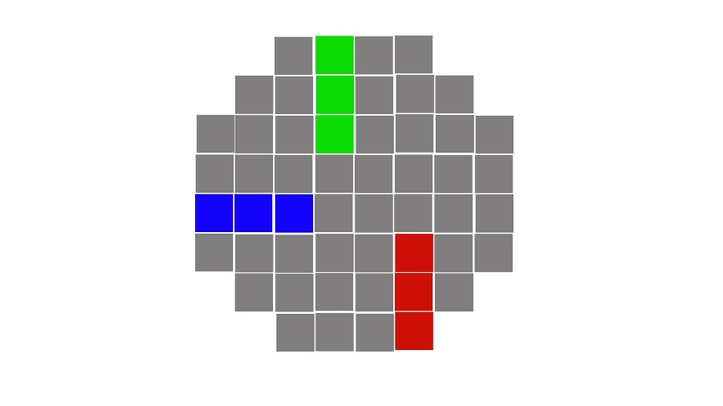The game was built around the concept of territorial acquisition with players taking territory in the form of square game tiles, and then competing for those tiles by taking calculated risks with the game favouring the defender in territory competition

**A**

# 1.1 Materials

To create the game prototype Construct 3 was used. Microsoft PowerPoint was used to create the presentation, and Microsoft Teams was used to distribute the game between players

**B**

Figure 1(A: blank spaces, B: Red players squares)

# 1.2 How to play

1. 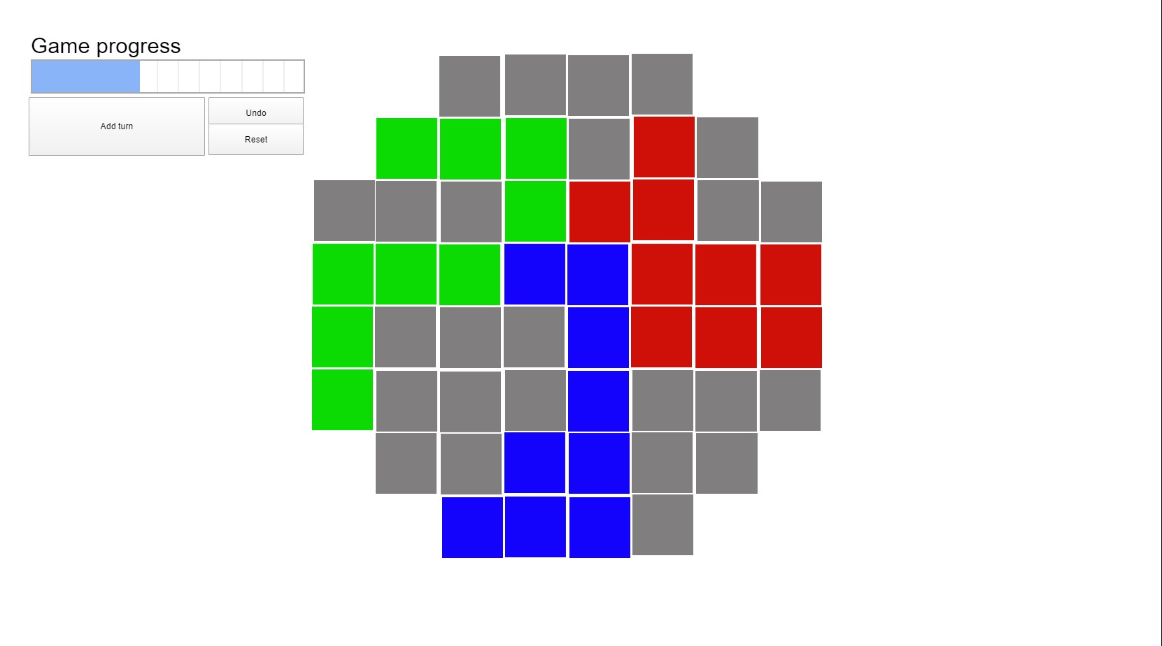The game requires three players to play
2. Each player picks one colour either Red, Green or Blue
3. Players then take turns moving three spaces either in a straight line or an L shape (players can only start their movement from a space that contains their own colour and can claim up to 3 spaces in total)

**+1**

**+1**

**A**

1. If a player tries to take a space from another colour than their own they must roll a dice adding an extra dice per adjacent square. The player who gets the highest roll gets to take the square(in the case of a tie the attacking player wins the square) bonuses from the squares they have adjacent are shown in Figure 2

**+1**

1. After each turn, players add a point to the turn counter Figure 3 and after ten turns the game ends, and the player who owns the most squares of their colour wins.

Figure 2(A: Square blue wants to take) red would get to roll 3 dice while blue would only roll 1



# 1.3 Rules

If a player does not have any of their colour left on the board that player loses as they cannot continue to claim squares

**C**

**B**

**A**

**D**

When the timer runs out the player with the most squares of their colour wins (grey squares are not counted)

Figure 3(A: Add turn button – adds a turn to the counter, B: game progress bar – when this bar fills the game is over, C: Undo button – removes a turn from the counter, D: reset button – resets the counter to 0)

To decide who goes first each player may roll one dice with the person who rolls highest getting to go first

# 1.4 Playtesting

1 Complete internal playtest of the game took place between the team members. During this playtest it was discovered that keeping track of turns was difficult and therefore after the playtest a turn counter was added.

No external playtesting took place as a suitable team could not be located within the time limit

# 1.5 Teamwork

The benefits of working in a team for this task was primarily the ability to multitask as one person could be making the PowerPoint while another was creating the game and yet a third was designing and refining the game rules.

Communication within the team was important especially after the playtest in which constructive feedback was gathered, and small refinements to the rules were implemented

# 1.6 Team members

* Giancarlo Trinidad
* Zakaria Ahmed
* Cory Arnett-O'Brien